**ITE3714: Multimedia Website Design Practices**

# **Lab 4 – Introduction to CSS**

1. Create a folder named **lab4** in Desktop
2. Download **"lab4_student.zip"** from Moodle
3. Unzip **"lab4_student.zip"** and put it in folder **lab4**
4. Open **"lab4_student.html"** using Notepad++ and Google Chrome
5. In the **<head>** tag, add the following CSS code

|  |
| --- |
| <style type="text/css">  body  {  background-color: #FCF3CF;  }  </style> |

1. In the **<h1>** tag, add the following attribute **class="heading"**

|  |
| --- |
| <h1 class="heading">IVE Foundation Diploma (Information Technology)</h1> |

1. In the **<h2>** tag, add the following attribute **class="sub_heading"**

|  |
| --- |
| <h2 class="sub_heading">Major IT modules:</h2> |

_

1. In all **<li>** tag, add the following attribute **class="body_text"**

|  |
| --- |
| <ul type="square">  <li class="body_text">Programming Concepts and Applications</li>  <li class="body_text">Database Applications Development</li>  <li class="body_text">Computer Systems and Communication Fundamentals</li>  <li class="body_text">Multimedia Website Design Practices</li>  …  <ol type="I">  <li class="body_text">Higher Diploma</li>  <li class="body_text">Undergraduate Programme</li>  <li class="body_text">Postgraduate Programme</li>  </ol> |

1. In Notepad++, create a file **"lab4_style.css"** in the folder **Lab4**
2. Add the following CSS code in the CSS file you created in Step 9

|  |
| --- |
| .heading  {  font-family: Arial, Helvetica, sans-serif;  font-size: 36px;  color: #69F;  }  .sub_heading  {  font-family: Verdana, Geneva, sans-serif;  font-size: 18px;  color: #F0F;  }  .body_text  {  font-family: Verdana, Geneva, sans-serif;  font-size: 14px;  color: #00F;  } |

1. Click the file **"lab4_student.html"**
2. In the **<head>** tag, add the following HTML statement

|  |
| --- |
| <link rel="stylesheet" type="text/css" href="lab4_style.css" title="style" /> |

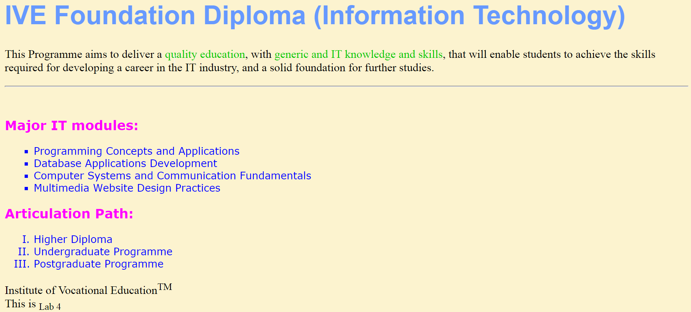

Challenge –

1. Add Inline Style of green color (#0C0) to the words “quality education” and “generic and IT knowledge and skills” in the first paragraph.

B. W3C Validator

1. html5 Validator

Add DOCTYPE tag to the 1st line of your html file to declare the version of your html file.

|  |
| --- |
| <!DOCTYPE html> |

Validate your HTML page (by copying all the codes of your html file) to make sure that it matches the html5 specifications. Run the validator from <http://validator.w3.org/> .

1. CSS Validator

Validate your CSS code (by copying all the codes of your css file) using the validator from <http://jigsaw.w3.org/css-validator/> .

Source Codes for your reference:

